**This manual will guide you on how to set up your HCL laptop for the first time.**

It is always recommended to carefully go through the whole document and read it while you set up your HCL laptop.

**Table of Content:**

1. BitLocker
2. Login to Laptop with your HCL Credentials

1. Password Policies

1. Setup Microsoft Outlook / Skype For Business
2. Laptop Declaration in TARMAC
3. Data Backup on One Drive

**Step 1:****BitLocker:**It is mandatory in HCL that all laptops should be encrypted with BitLocker Encryption Tool, therefore, we have already installed BitLocker Encryption on your laptop the following steps will help you on how to unlock your laptop:

1. Turn on the power of your laptop
2. After the Laptop Mafucture logo, you will get BitLocker Screen
3. 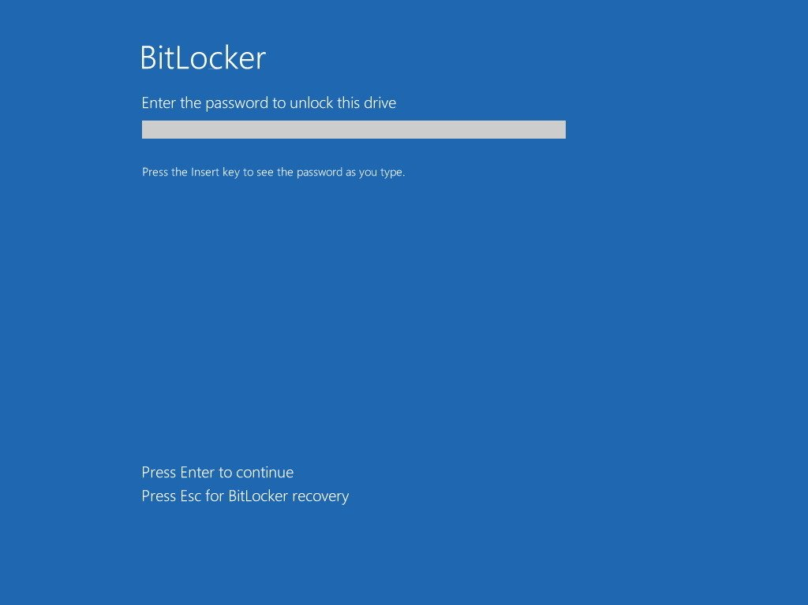Enter the default BitLocker Pin Code which was shared to you by IT Team

1. Once you have entered your BitLocker Pin Code the laptop will load to Windows logon page. (**The Second Step will guide how to log in with your HCL Credentials**)

**Step 2:**

**Login to Laptop with your HCL Credentials:**The following steps will guide you on how login to your HCL Laptop with your HCL Credentials for the first time.   
  
**NOTE: *If your laptop has been re-imaged with the new Windows version follow the same steps to log in with your HCL credentials.***

1. When you are at the Default Login Screen, where it is prompting you for your username and password, click on the icon that looks like two monitors as seen here:

**NOTE: *Make sure that your laptop is already connected to any open internet. The VPN tool will not work if your laptop is connected to the client network.***

1. Once you have clicked on the icon you will see a Cisco AnyConnect logo in the center of the screen. Then a Cisco AnyConnect box will pop up, it should look like the image below, with ***myvpn-eu.hcl.com/TGHCLSBL*** as the address. Click on the Connect button, then enter your HCL username and password, then click OK:

1. You will now notice an additional icon in the lower right-hand corner, this means that you are now connected, now proceed to login as normal by proceeding to log in for the first time in the username field enter your full HCL email address.

**NOTE: *If you’re a new user on the second screen the window will ask you to change your password.***

**STEP 2.1:**

**Password Policy**

This step will guide you about HCL Domain password policy and BitLocker PIN Code.

1. BitLocker PIN Code will stay the same it will not get expired every 60 Days.
2. The HCL Domain Credential password will get Expired every 60 days and the users will get notification both on email and on windows notification center. The following steps will guide you on how to change your domain password so it can get sync properly to avoid any issue.
   1. If you’re in HCL Office follow these steps:

2.1.1. Press Ctrl + Alt + Delete

2.1.2. Click Change Password Link

2.1.3. Click OK once you have entered the new password

2.1.4. Password has been changed

* 1. If you’re working from Home or Client Location follow these steps:

2.2.1. Sign out from current windows session to windows default login page

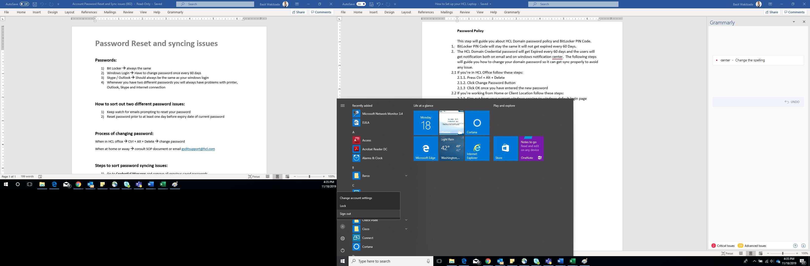

2.2.2. From the windows default login page connect the laptop to the Cisco Anyconnect VPN as described on step 2.

2.2.3. Once you’re connected login to windows with your HCL Credentials

2.2.4. From the current windows session Press keys \ together on your keyboard to get the change password screen.

2.2.5. Click on ‘change password’:

2.2.6. Specify the new password for your user account

**NOTE:** ***It is advisable to have one password for Your Outlook/Skype for business and Windows, in this case, you won’t face any problem with synchronization/network connectivity etc…***

2.2.7. In case of any password syncing issue follow these steps to resolve it:

**Step1:**

* Go to **Credential Manager** from Start Menu and remove all the saved passwords.

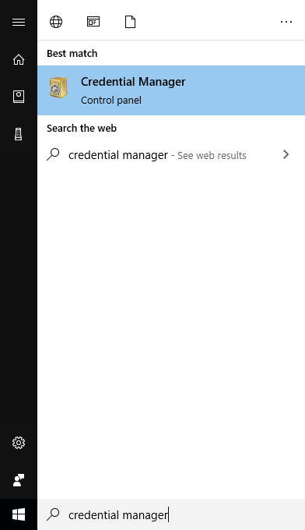

**Step2:**

* Press Windows button + R to open Run
* Type %temp% in Run Field

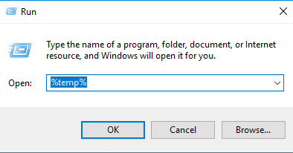

* The Temp folder will now open
* Select all the files there, right-click and choose delete, or simply hit the Shift+ Delete button on your keyboard to permanently delete the files.

**NOTE:** ***You may not be able to delete all the files. This is because Windows won’t let you delete the files that are currently in use.***

**Step3:**

* Press Windows button + R to open Run

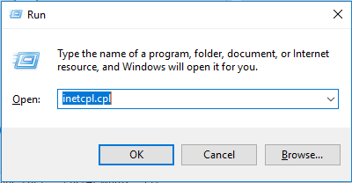

* 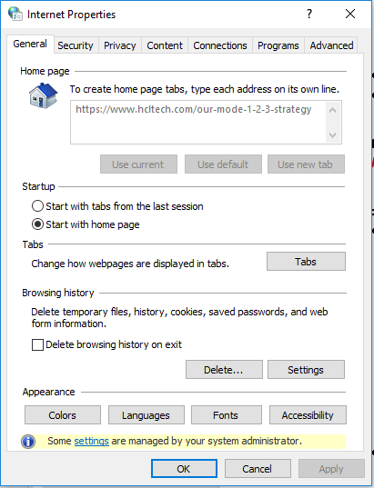Type inetcpl.cpl this will open internet properties
* Delete browsing history
* Click Settings next to Delete button
* Click View files
* Select All Files by pressing Ctrl+A on your keyboard and then Delete all the files by pressing Shift +Delete on your keyboard
* Restart your Laptop.

2.2.8. In case of any issue contact [gsditsupport@hcl.com](mailto:gsditsupport@hcl.com).

**Step 3:**

**Set up Microsoft Outlook / Skype For business:**

This step will help you on how to set up your Microsoft Outlook / Skype For Business for the first time once you have received your HCL Laptop.

**Microsoft Outlook:**

1. Open Microsoft Outlook from Start menu

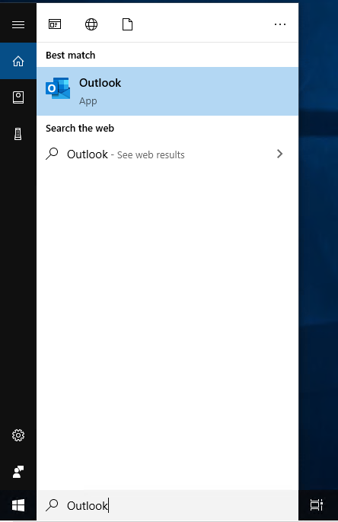

1. You will see outlook email set up screen enter your HCL email address if it is not written automatically already > Click on Connect button

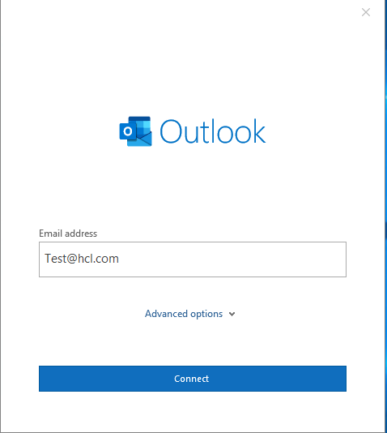

1. If you have not set up outlook on your phone already select Set up Outlook Mobile on my phone, too and then select Done button.

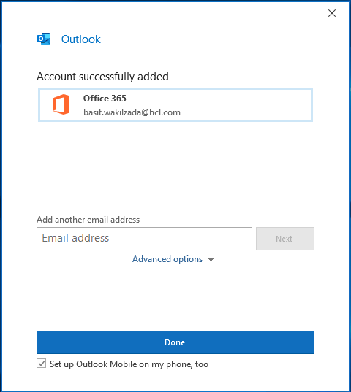

1. Outlook Window will start loading.

**Skype For Business:**

1. Open Skype For Business from Start Menu
2. Enter your HCL email address if it is not written already

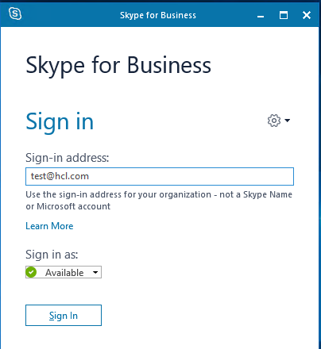

1. Click Sign In
2. If Prompt Enter your password
3. Skype For Business will Sign in.

**Step 4:**

This step will help you with how to declare your laptop to TARMAC (TARMAC is HCL’s internal portal which assists in the process of Software Asset Management).

1. Open Browser (IE or Microsoft Edge)
2. Enter <https://tools.hcl.com/tool> in the browser address bar
3. Sign in with your HCL Domain Credentials
4. Download Soft Scan Tool Before Laptop Declaration

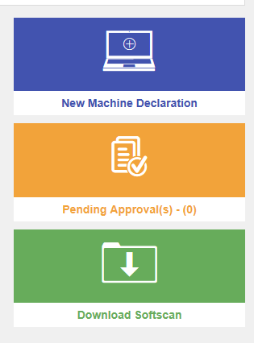

1. Run the Softscan.exe once the download has been finished

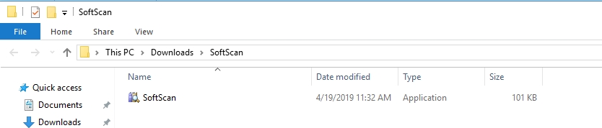

1. A screenshot of a cell phone

   Description automatically generatedSoftscan tool will open as shown in the following screenshot

1. Enter the Captcha Text > Click on Scan button > Wait for Softscan to finish the scanning this may take more than 10 to 15 minutes.
2. Once the scanning has been finished you will get a successful pop-up message.
3. Go back to your browser where you have already open TARMAC
4. Click on New Machine Declaration



1. Machine Declaration page will open as the following screenshot

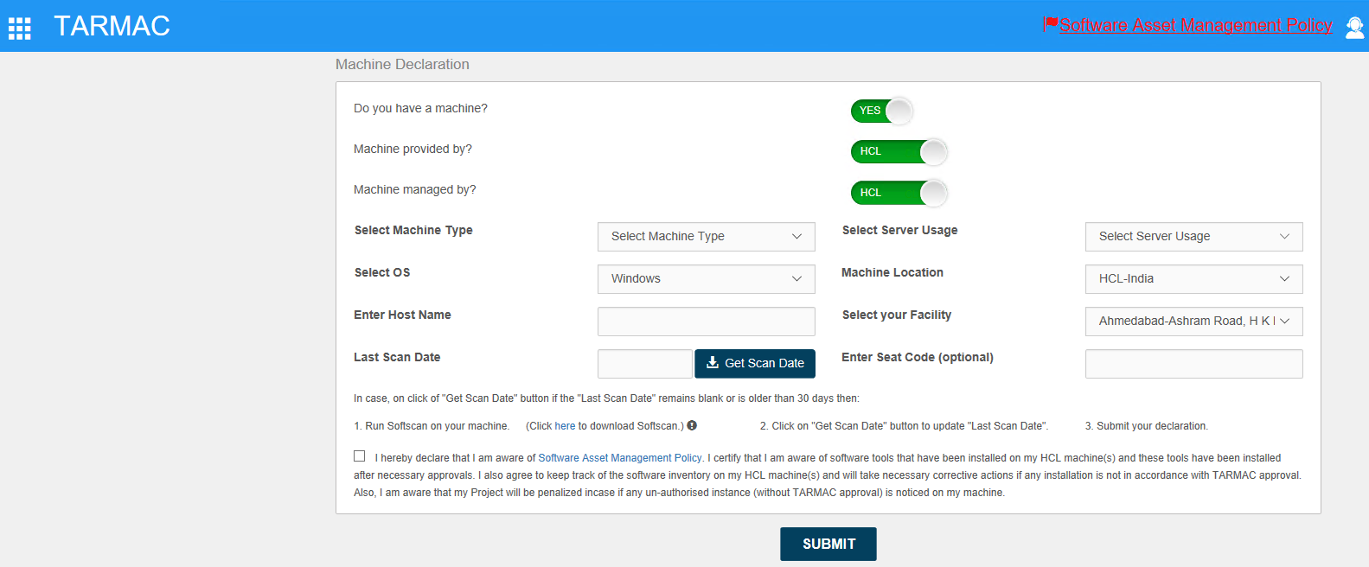

1. Fill in the fields.
2. To get Hostname > Open Command Prompt > Type Hostname > Enter
3. Click Get Scan Date button to fill last scan date field
4. Click Submit button

**Step 5:**

This step will guide you on how to setup One Drive and get your computer data backed up.   
**Note: *Data backup is users responsibility, GIT has already provided the infrastructure where every user has 1 TB space on HCL One drive. It is user responsibility to upload his data to HCL one drive space.* *In case if your laptop stopped working and you have not back up your data already to OneDrive then the IT Team will not be able to recover the files that you have lost.***

1. Click Start button > Search for One Drive > Open it.

1. When OneDrive Setup starts, enter your work or school account, and then select Sign in.

1. On the next screen, you’ll be shown the location of your OneDrive folder. By default, your files will be saved in your personal folder on your system hard drive. You can change where OneDrive syncs to by clicking the “Change Location” button. This cannot be altered once you’ve completed OneDrive setup so you should check you’ve got enough storage space left for your future file. Click Next to save the location.

1. A screenshot of a social media post

   Description automatically generatedOnce you press the “Next” button you will get to the final set up screen which confirms everything is ready to sync. When you close the window, your files will start to download to your PC. If you need to change which folders are synced in the future, right-click OneDrive’s tray icon and click “Settings.” The “Choose folders” button will let you access the sync window again so you can download more folders or exclude ones that are getting too large.